|  |  |
| --- | --- |
| Image result for masterspace solutions  **COMPANY PROFILE** | |
|  | **Company Address:**  Masterspace Solutions Limited  Industrial Complex, Mombasa Road  P.O Box 57933, 00100  Nairobi, Kenya  T : +254 715 837 832 /+254 772 174 759  E :  [info@masterspace.co.ke](mailto:info@masterspace.co.ke)  W: [www.masterspace.co.ke](http://www.masterspace.co.ke) |
|  | |
|  | |

# **Table of Contents**

**Table of Contents** 2

**1****Introduction** 4

1.1 About Masterspace Solutions LTD 4

1.2 MSS Culture & Core Values 5

1.3 MSS Team & Organization Structure 5

**2****About our services** 8

2.1 Introduction 8

2.2 We can help if: 9

**2****Project Management as a service** 10

3.1 Introduction 10

3.2 The Solutions 11

3.2.1 Module #1: Project Concept Development 12

3.2.2 Module #2: Project Timely Execution 12

3.2.3 Module #3: Project Audit and Quality Assurance 13

3.3 Buy the Service 14

3.4 Summary 14

**4****Product Development & Management as a service** 15

4.1 Introduction 15

4.2 The MSS Approach 16

4.2.1 Product Team Workshop 16

4.2.2 Product Portfolio Analysis 17

4.2.3 Outsourced Product Development 17

4.2.4 Interim Product Manager 18

4.3 Why MSS? 18

4.4 Summary 19

**5****Reseller Partnerships** 20

5.1 Introduction 20

5.2 Who can we support? 21

5.3 Digital Transformation: Reseller Partnerships 22

5.4 Summary – Why MSS? 22

# **Introduction**

## About Masterspace Solutions LTD

Masterspace Solutions Limited (hereafter abbreviated as, MSS) was founded in June 2009. MSS core business is in the domain of ICT consultancy services focusing on *four* main product offerings: ***ICT Research and Innovation as a Service***, ***Project Management as a Service***, ***Product Development & Management as a Service***, and ***Reseller Partnerships as a Service***. Our operating mechanism is to deliver to our customers’ solutions that in no doubt elevate and transform their businesses to deliver real and ‘*Tangible Results’*. When you work with us, you are working with experts. We combine deep business and industry insight in projects and products development with digital innovation. Our diverse teams of creative, industry and technology professionals help accelerate the successful impact in businesses and technology industry players across the region.

We believe in partnerships. That is why our team will go the extra mile to acquaint ourselves with your venture, your needs, your strengths, your weaknesses, and your goals, both for the short term and the long term. Then, we’ll develop a focused strategy to help drive your sales, boost your profits, expand your reach, and even open the door to new opportunities!

Understanding that your organization needs to improve is one thing; knowing precisely how to effect that change in a practical, efficient manner takes a well-developed strategy and lots of expertise — expertise that you’ll find in our team here at MSS. Working with us allows you time to concentrate on your core business, we shall worry about the details on your behalf.

Quite simply, our expert consultants, strategists and executive coaches will help you gain the momentum you need to thrive! We know the types of challenges and obstacles you face as you strive to grow and expand. That’s why as MSS, we have heavily invested in Research and Innovation.  Because even in Project and Product Portfolio Management, there’s no such thing as a one-size-fits-all business, so a generic, one-size-fits-all solution simply doesn’t make sense. Every organization is unique, and we don’t rest, until we perfect our work for you, to develop a one-of-a-kind solution for your one-of-a-kind company!

Technology is an important enabler of business transformation. To assist you in getting value from technology investments, we bring together the skills to deliver improvements in processes, as well as the knowledge in strategy, architecture and design, enterprise applications, sourcing, project management and operations management, product development and Reseller Partnerships.

In Summary, our approach cuts through the clutter to identify how your core business capabilities stack up to opportunities for growth. We’ll help you apply and scale your strengths to drive your business forward.”

## MSS Culture & Core Values

**Vision:** A holistic approach to service delivery and total transformation to our client’s business.

**Mission:** Provide world class ICT consulting services to our clients focused on the following core areas, Projects, products, and ICT Research and Innovation.

**Core Values:** Innovative, Integrity, Reliability, efficiency, and Effectiveness

## MSS Team & Organization Structure

Masterspace Solutions Limited was founded by a team of Kenyan industry veterans with accomplished track records in all areas of ICT business operations; such as: ICT Research and Innovations, Strategy Development, Projects and Products Management and Reseller Partnerships with various industry vendors – bringing a strong balance of “real world” insight and strategy-based competence.

* ***We work collaboratively with clients***

–We strive to become an integrated and transformative partner with our clients, serving as an extension of management and professional teams. We don’t deliver and depart; we partner with you to deliver a solution.

* ***We deliver pragmatic and realizable solutions***

–We apply our experience to focus quickly on core opportunities with the highest return and develop innovative, pragmatic solutions for implementation with sustainable results.

* ***We are independent***

–We focus on client advisory services before we recommend a solution. We are not just a provider of outsourced services, software, or hardware technology. As an independent advisor, we are unbiased and solely focused on our clients’ returns.

* ***We are a people business***

–Our client service philosophy recognizes that world-class advisory is delivered by talented and world-class professionals. Next to our clients, our people are our greatest asset. That’s why we believe in “***Tangible Results***” our solutions are supported by empirical research.

**Our Management Team**

The business is driven by our 6 working founders; collectively they have accumulated more than 90 years of work experience in the ICT industry. They are involved in the business development, procurement, project and product management and administration of the company.

The management team proactively gathers feedback, identifies changes in business environment, reviews work processes and communicates key learning points and company policy to all staff at regular meetings.

**Our People**

Our people are crucial in the delivery of our services and solutions to our clients. To ensure that everyone is equipped with the right skills, knowledge and attitude, a comprehensive training programme is put in place to constantly upgrade our people in technical and management skills. We believe firmly in providing the right training, accredited certification, and practical knowledge for our people, for them to execute their duties and responsibilities confidently. Our aim is to stay relevant to the ever-changing marketplace and client’s requirements.

**Our Contact Information**

**Physical Address:** Industrial Complex, Mombasa Road, Nairobi, Kenya

**Postal Address:** Box 57933, 00100 Nairobi, Kenya

**Telephone:** +254 773 499 346 / +254 770 299428 /+254 720993917

**Email Address:** [Masterspace@Masterspace.co.ke](mailto:masterspace@masterspace.co.ke)

**Website:** [www.Masterspace.co.ke](http://www.masterspace.co.ke)

# **About our services**

## Introduction

1. At Masterspace Solutions Limited, we focus on providing Strategic ICT consulting as a service, provided by our top management consultants, who have a wide expertise in business processes cutting across in the digital value chain. Our strategic ICT consulting projects are focused on ICT infrastructure, Masterplan development, project delivery management, data integration or business intelligence and risk management.
2. Our strategic management solutions include three aspects – business, analytical, and technological. Therefore, we employ long-term knowledge of various business processes from different industries and business segments, proven know-how from various implementation strategies, and experience in implementing various analytical methods and systems when developing features in this area.
3. Strategic consulting is provided by our most experienced consultants who have extensive expertise in business processes in most industries and are proficient in the design and implementation of different types of ICT strategies. We use a proven methodology that accelerate and simplify the strategic management of each enterprise.
4. Realization of strategic ICT consulting project can help you design development strategies for your information systems or delivery of complex integration projects and solutions in a seamless manner . Our professional knowledge and experience ensure the maximum stability, scalability, and integration of ICT systems at minimal cost.

## We can help if:

* You recognize the need to better align IT to the organization’s needs
* You wish to have the right IT organization to support business requirements and increase value to the business
* You need to be better equipped to perform IT due diligence activities for mergers and acquisitions
* Your efforts to comply with regulatory matters have uncovered operational issues in IT and information security
* You need to prioritize and measure IT projects
* You wish to assess which IT services should be provided internally and which should be outsourced to third party service providers
* IT is seen as a constraint on the business or where the reputation of IT is held in low regard
* You are seeking ways to improve the effectiveness of relationships between IT, the organization and with suppliers
* You want to evaluate how your product-line is fairing, which is one working, which one needs revision.

# **Project Management as a service**

## Introduction

The increasing demand for e-government services has created considerable challenges for public administration, not only in terms of expertise and experience that are required in order to run development projects, but also from organizational, cultural and legal perspectives. In fact, the ongoing modernization of public administration functions is realized through a large number of complex and technology intensive projects. Most of them are co-financed by the multi-lateral donors within the framework of Community Development Programmes. The need for effective implementation of such projects in compliance with the donor directives and for the seamless integration of their outcomes into the organizational structure, has driven public administration officials to seek alternative means for enhancing the operational effectiveness of departments involved in project implementation and for supporting functions related to the utilization of project results and change management. MSS objective is to be a partner of choice for managing the full scope of some of these complex integration projects, be they public or private sector focused in a timely and cost-effective manner.

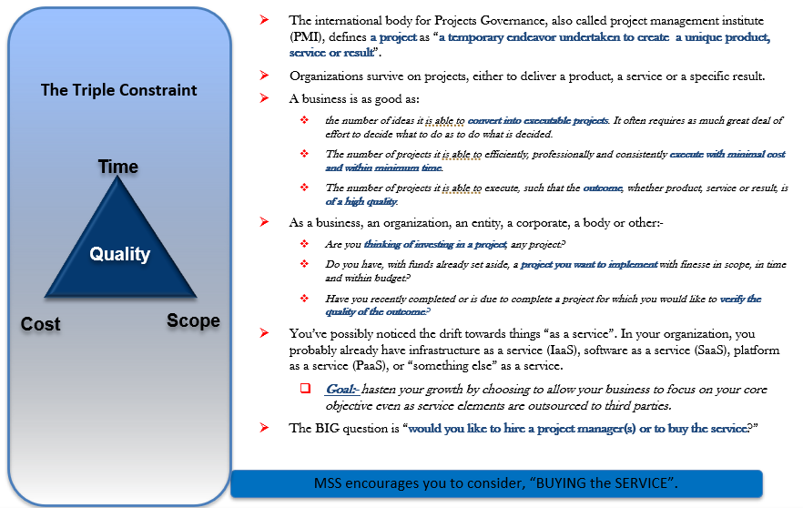

## The Solutions

We have designed three modules of Project Management Engagements steps. Each module can exist independently and can be customized based on need.

All the modules are aimed at either **enabling you decide** or **executing efficiently** or **assessing quality of outcome** or **ALL three** combined.

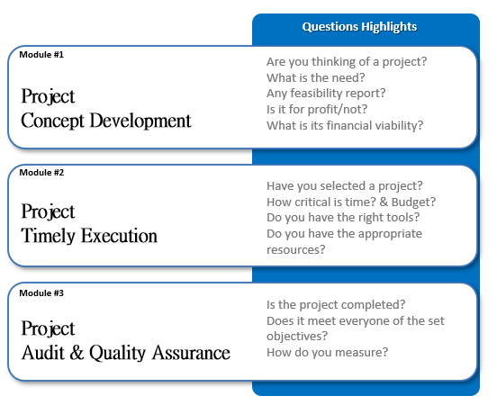

## Module #1: Project Concept Development

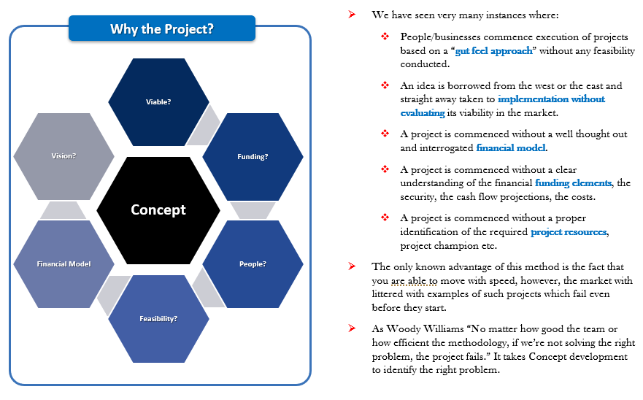

## Module #2: Project Timely Execution

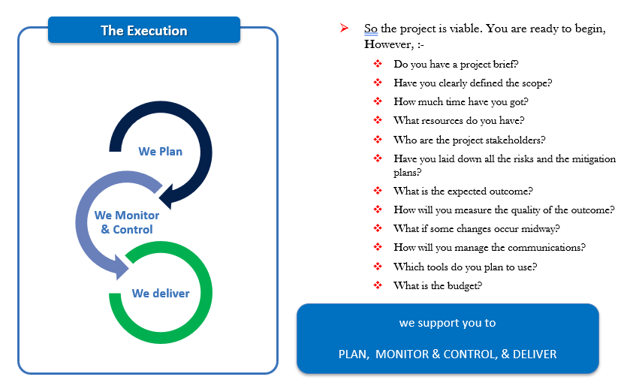

## Module #3: Project Audit and Quality Assurance

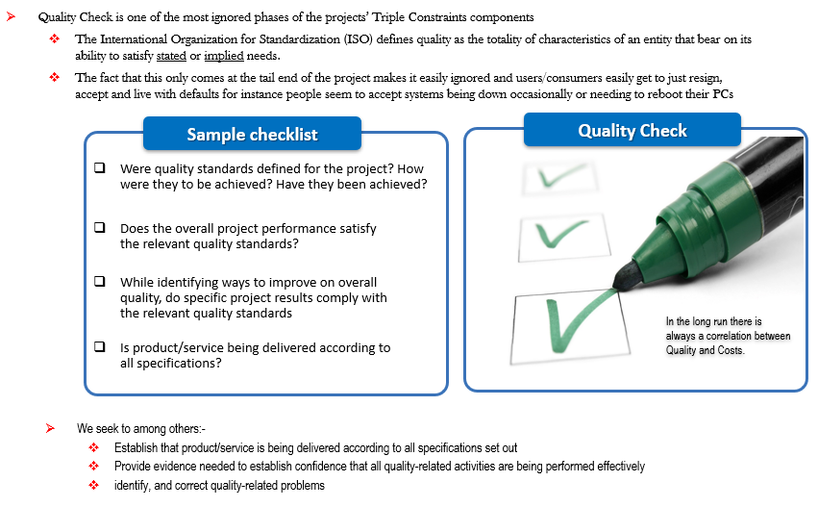

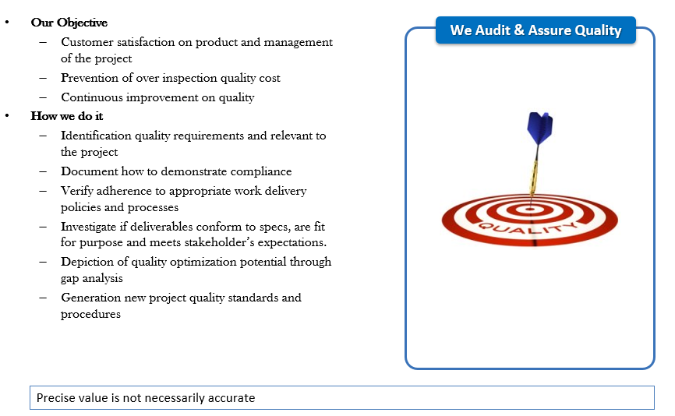

## Buy the Service

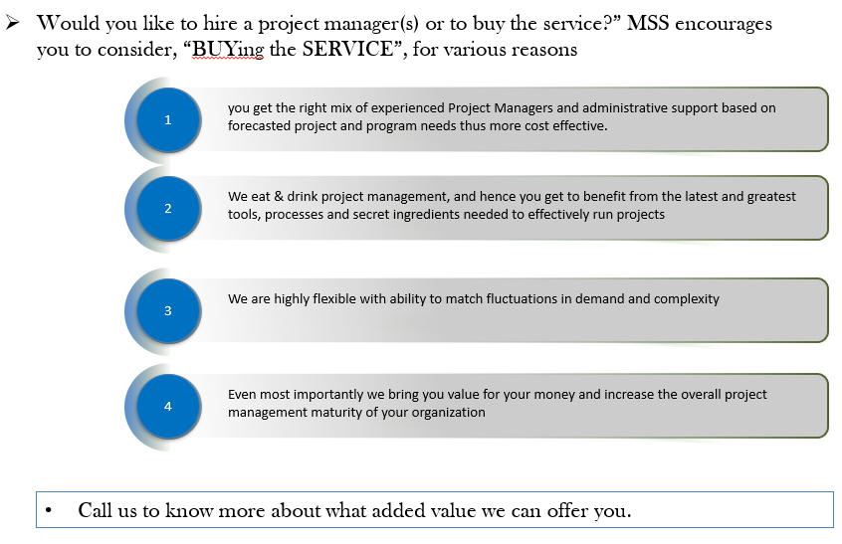

## Summary

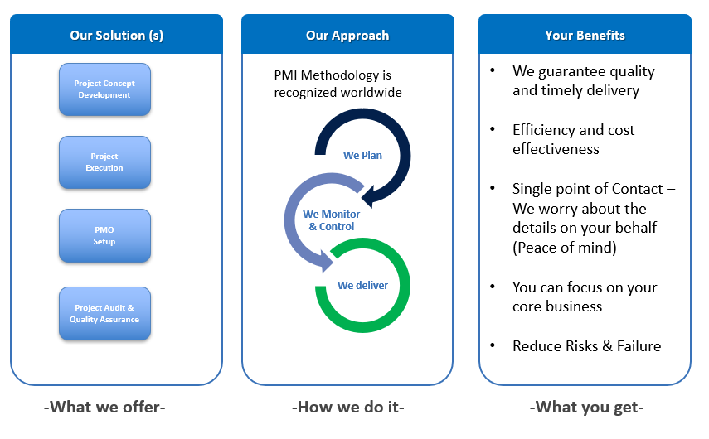

# **Product Development & Management as a service**

## Introduction

When a company or an organization is just starting out, it’s all about finding something that resonates with users and delivering real value to customers.  Its why startups are such great places for innovation.   But as the company starts to grow, very often the nature of the product organization changes into a group whose main purpose is to serve the needs of the many stakeholders across the business – business owners, sales, marketing, business development, legal, finance, operations, customer service, etc. Our objective at MSS is to support our partner organization to continuously innovate products and solutions that resonate well with the customers and end users. We help organization eliminate stale products through continuous market research and innovation on the product management service line.

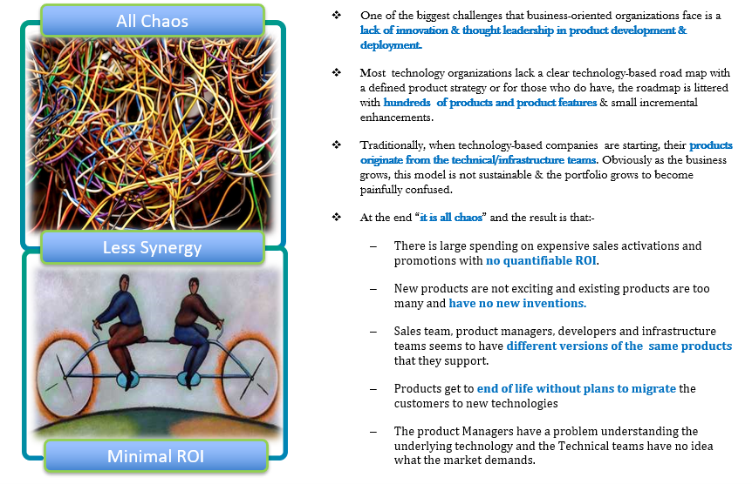

## The MSS Approach

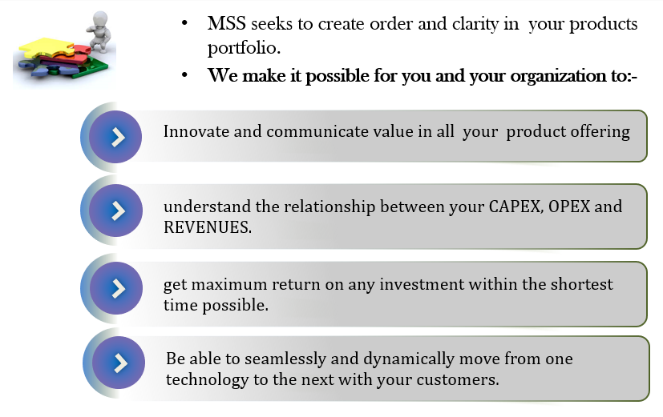

## Product Team Workshop

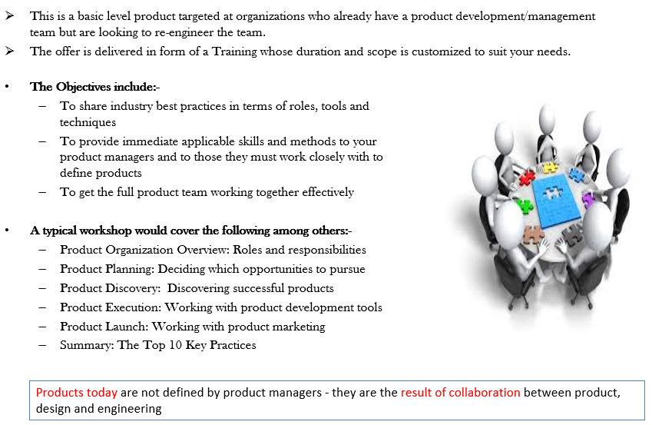

## Product Portfolio Analysis

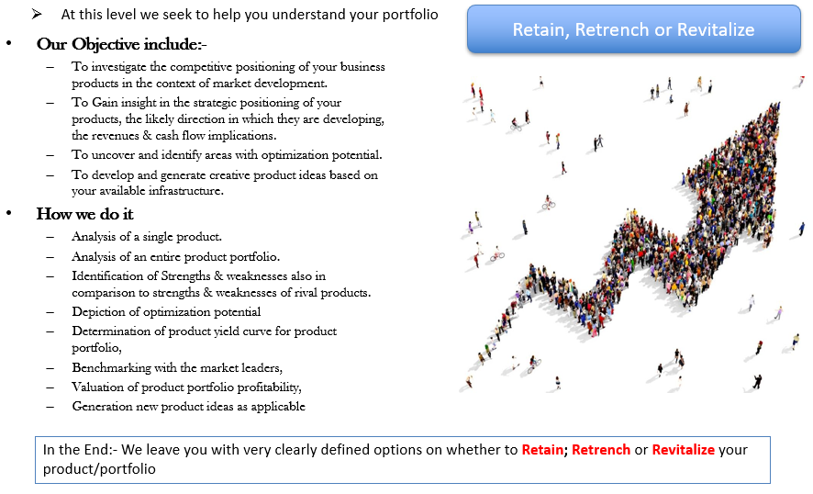

## Outsourced Product Development

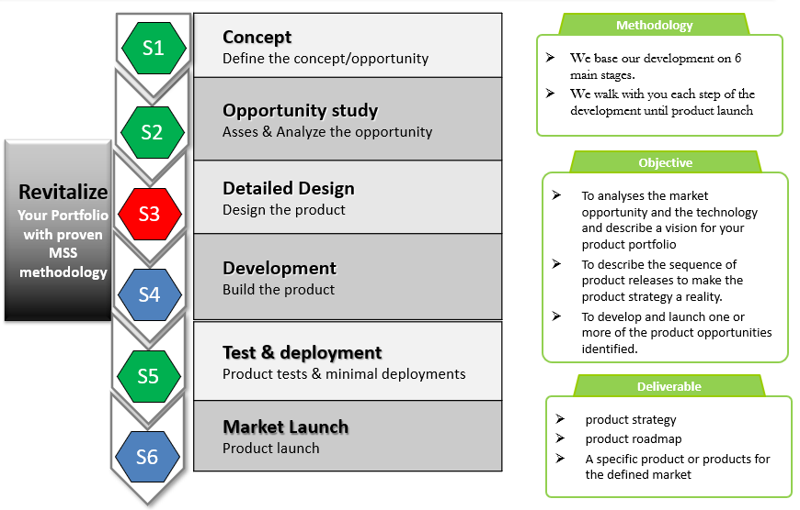

## Interim Product Manager

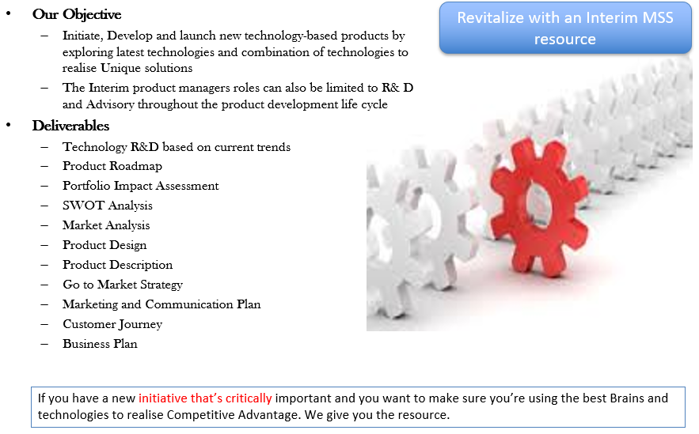

## Why MSS?

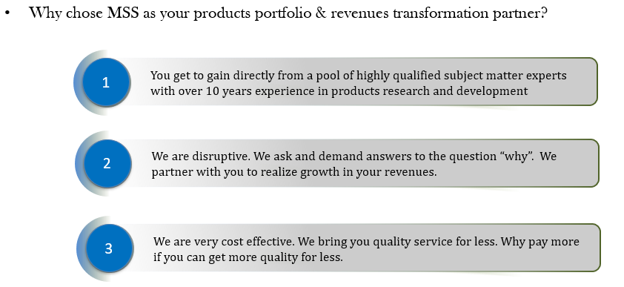

## Summary

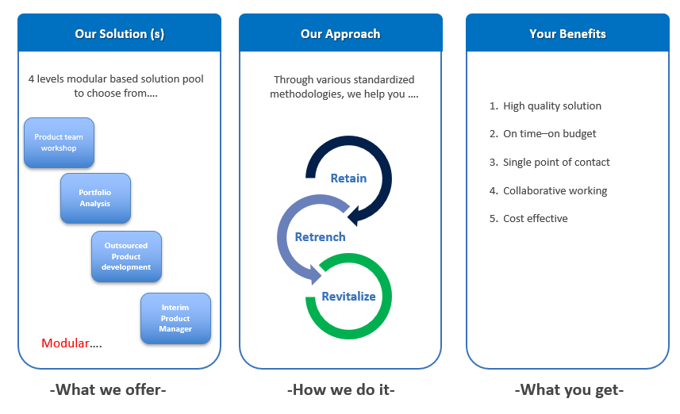

# **Reseller Partnerships**

## Introduction

* Digital transformation is offering new ways for organizations and enterprises to accelerate their operations and businesses by leveraging innovations**, mobility, Internet of Things (IoT), big data analytics / Artificial Intelligence, and social media** to drive better insight and speed in decision making.
* But before they can transform their businesses, organizations/enterprises need to transform their networks first, because trad\itional network architectures hamper **digital transformation** instead of propelling it forward.
* Masterspace Solutions has a product strategy that focuses on making digital transformation **Open, Programmable, and Scalable.**
* As a trusted ICT transformation partner, Masterspace will help Organizations and Enterprises develop a **“Stairway to the Cloud”** blueprint with best practices for your enterprise that takes the following into consideration: -
  + Transformation of your core data center architecture with significant advantages in cloud environments such as **High elasticity, Scalability and Optimized performance**.
  + Unify (“federate”) data centers into the cloud to enable new capabilities including: **Work mobility, Application topologies and Business continuity/Disaster recovery.**
  + Overlay for full end-to-end programmability to add and streamline important fundamental cloud operations enabling: **Full programmability, Automation and Workload mobility**.
  + Enable fast and reliable connections everywhere for **Resource optimization and Best performance.**
  + Expand customer communications and service options through a collaborative framework that offers new capabilities such as: **Customer Satisfaction, Globalization and Adaptability.**

## Who can we support?

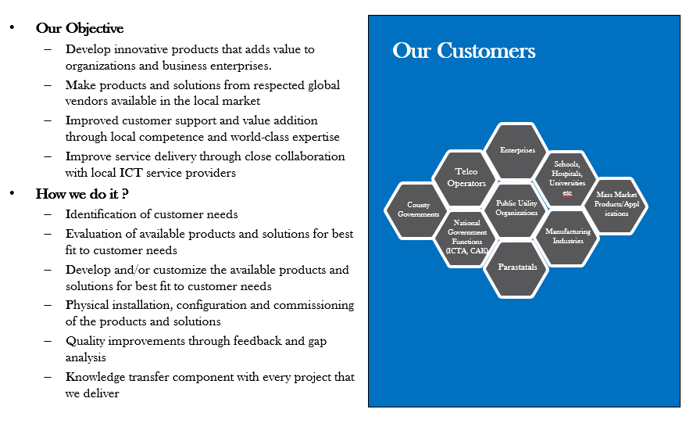

## Digital Transformation: Reseller Partnerships

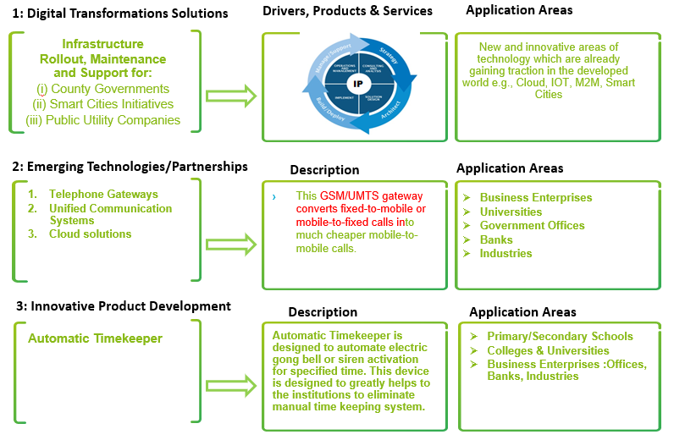

## Summary – Why MSS?

**Service is truly end to end**

Our Network Assessment isn’t just about infrastructure but captures network strategy for today and the future

**Technology Consulting Capabilities**

Network Architecture & Optimization

Technology Strategy & Planning

Operations, People, Processes

**Solution Deliverables:**

Alignment with Business Objectives

Reliability and Resiliency

Network Evolution & Scalability

Capacity Planning

Performance KPIs and Service Quality

Best Practices & Standards Alignment